Name: Lujain Zia

Roll no: 2023-BSE-034

Date: October 12, 2025

Assignment 1

Task 1: Run Gitea in Codespace and Create an Initial Repo

1. Set up Gitea:

- Run a Gitea server inside your Codespace.

- Use HTTPS for communication (SSH is not supported in Codespace).

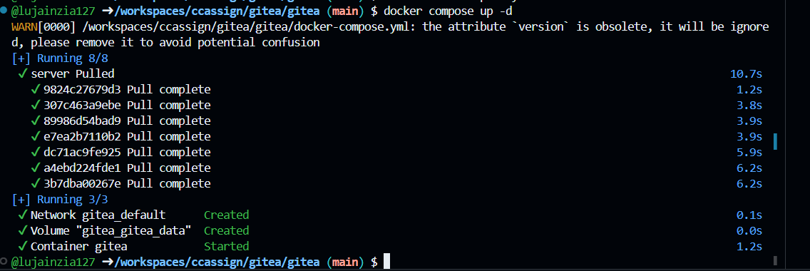

2. Create a Repository:

- Create a new repository on your Gitea server.

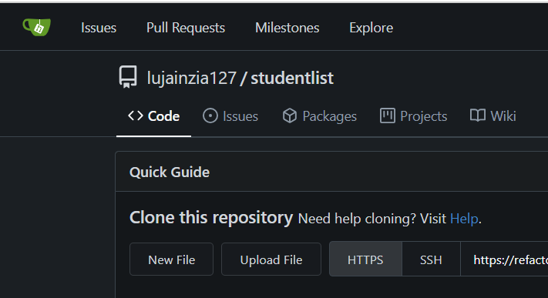

- Add a README.md file listing each student's name and roll number.

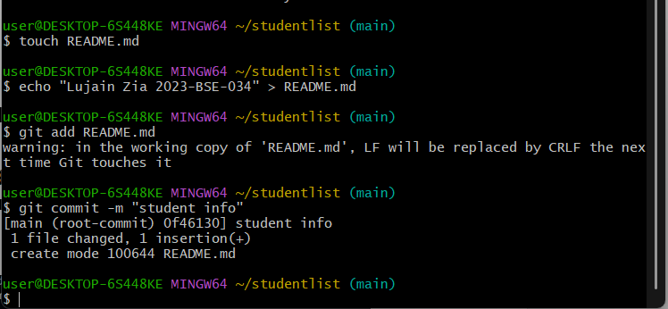

3. Add Remote Repo:

- Use the following command to add your Gitea repository as a remote:

git remote add gitea <your_gitea_repo_https_url>

- Push your initial commit containing the README.md to Gitea.

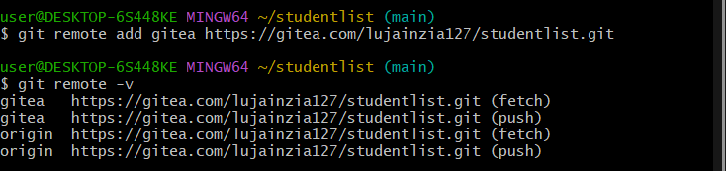

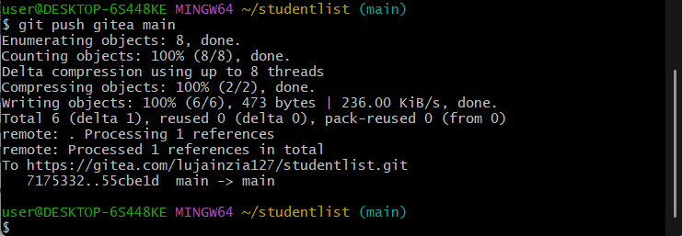

Task 2: Mirror README.md from Gitea to GitHub

1. Continue Working with Your Existing Repository:

- You will use the same repository that you created and pushed to your Gitea server in Task 1.

2. Create GitHub Repository:

- Create a new GitHub repository named assignment 1. (redone)

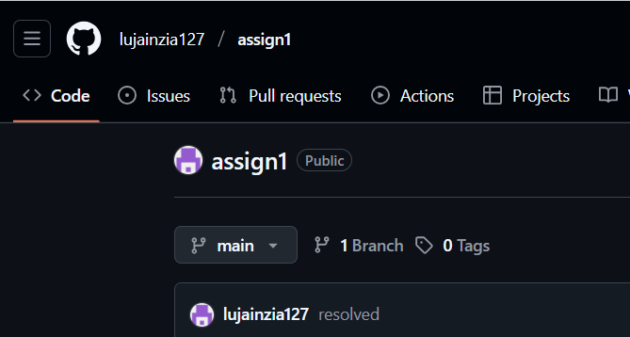

3. Add GitHub as a Second Remote:

- Add your GitHub repository as a remote to your local repository:

git remote add github <your_github_repo_https_url>

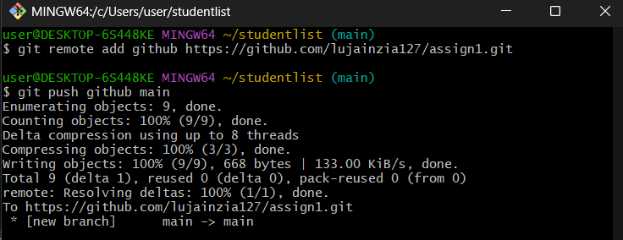

4. Push the README.md File to GitHub:

- Push the contents (including the README.md) from your local repository to GitHub.



5. Verify Remotes:

- Run git remote -v and ensure both remotes (gitea and github) are listed.

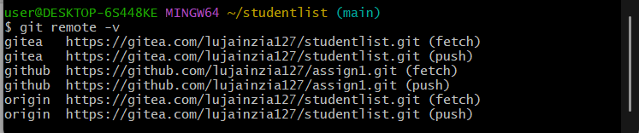

Task 3: Use Git LFS for Large Files

1. Install Git LFS:

- Set up Git LFS in your local repository.

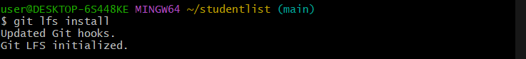

2. Add Large Files:

- Add three files larger than 100 MB each to your repository.

- Track them using Git LFS:

git lfs track "*.ext"

- Replace .ext with the appropriate file extension.

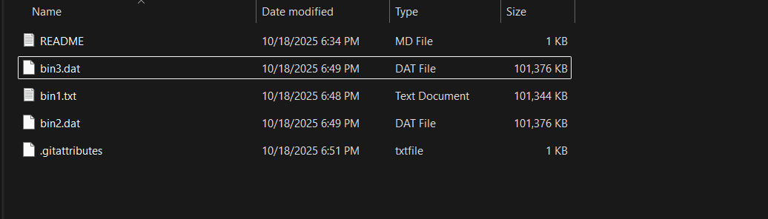

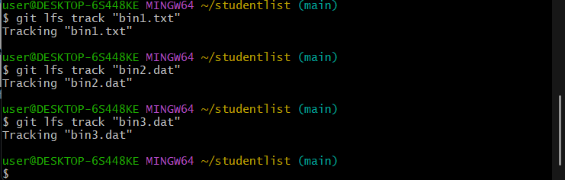

**3. Reference in Assignment Repo:**

**- Commit and push these large files to your GitHub assignment 1 repo.**

**- Ensure the files are referenced correctly in your repository history**

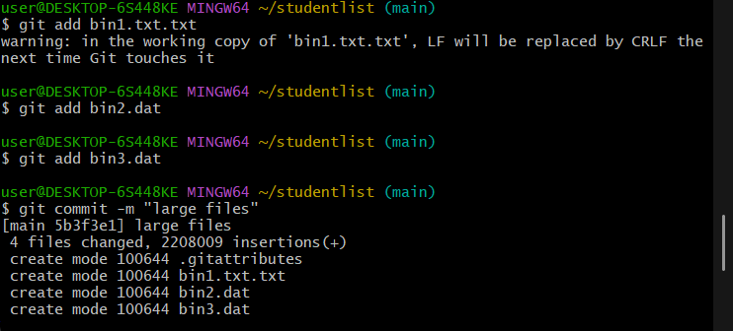

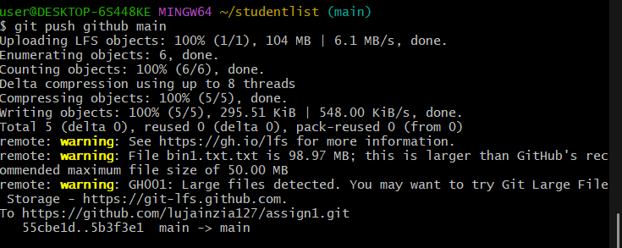

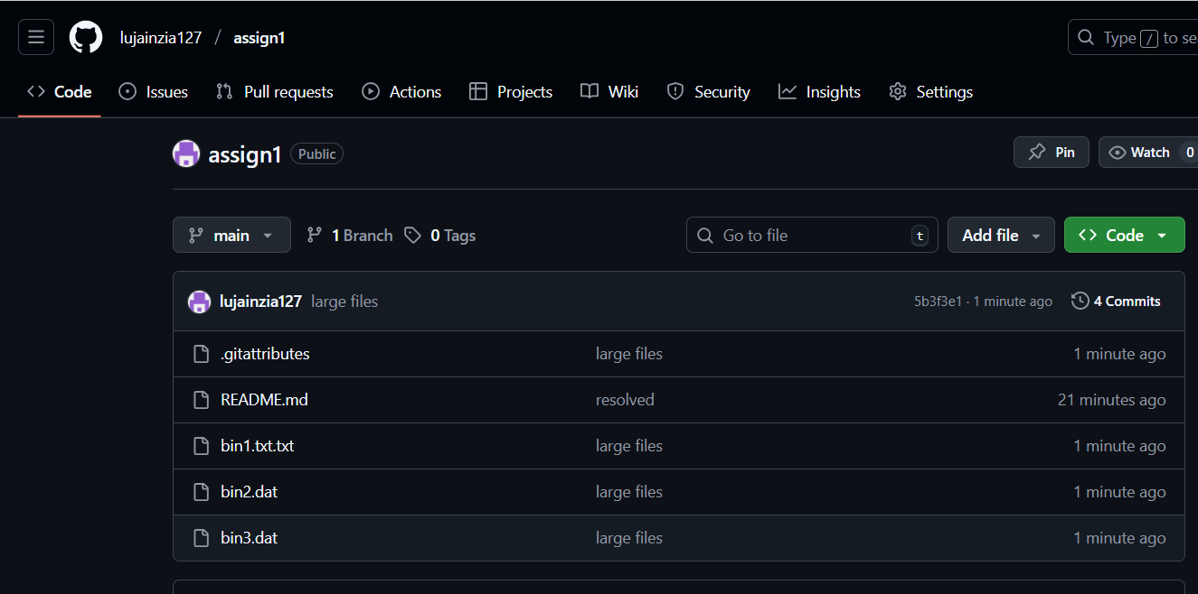

Task 4: Create a Portfolio/CV with GitHub Pages

1. Create a new repository for GitHub Pages:

- Create a new repository named <your-username>.github.io.

- Replace <your-username> with your actual GitHub username (e.g., johnsmith.github.io).

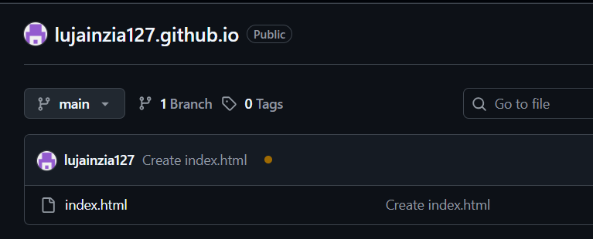

2. Design Your Portfolio/CV:

- Create your portfolio or CV in HTML/CSS (or use a static site generator).

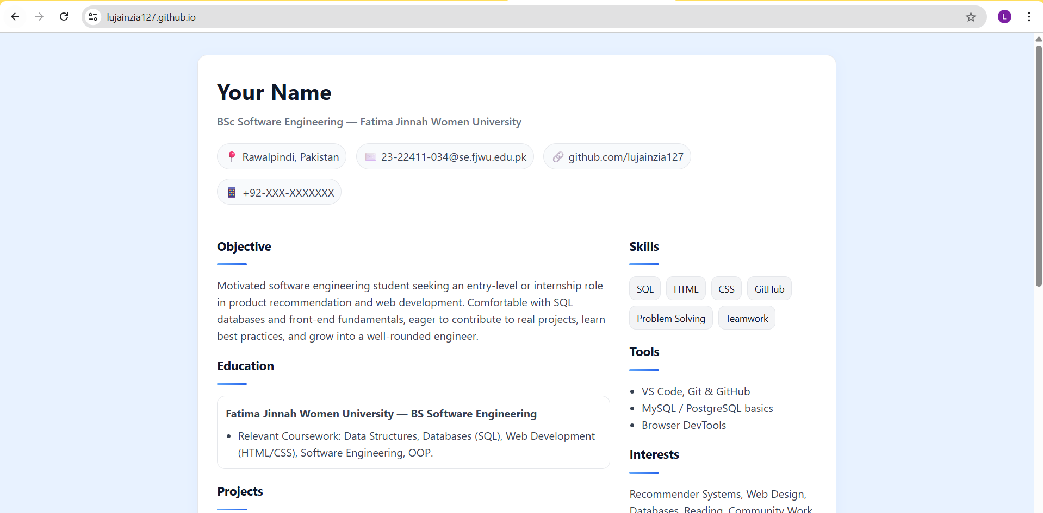

3. Publish with GitHub Pages:

- Push your portfolio/CV files to the <your-username>.github.io repository.

- Enable GitHub Pages in your repository settings if not automatically enabled.

- Publish your site and share the link.

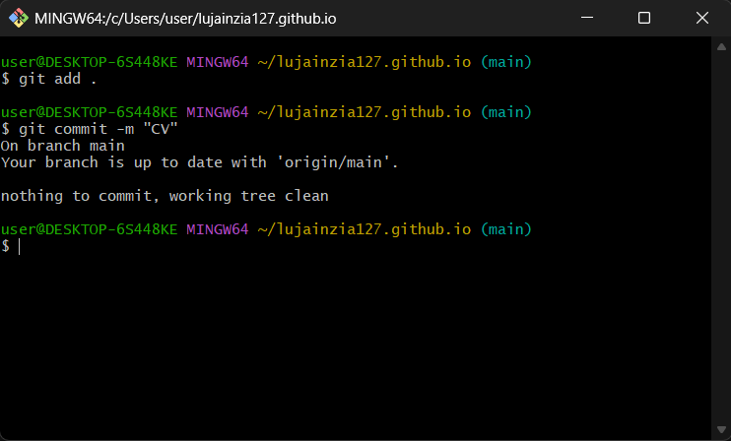

Webpage link: <https://lujainzia127.github.io/>

Gitea repo link: <https://gitea.com/lujainzia127/studentlist>

Github repo link: <https://github.com/lujainzia127/assign1>

